Range Therapy developer manual

Dataflow
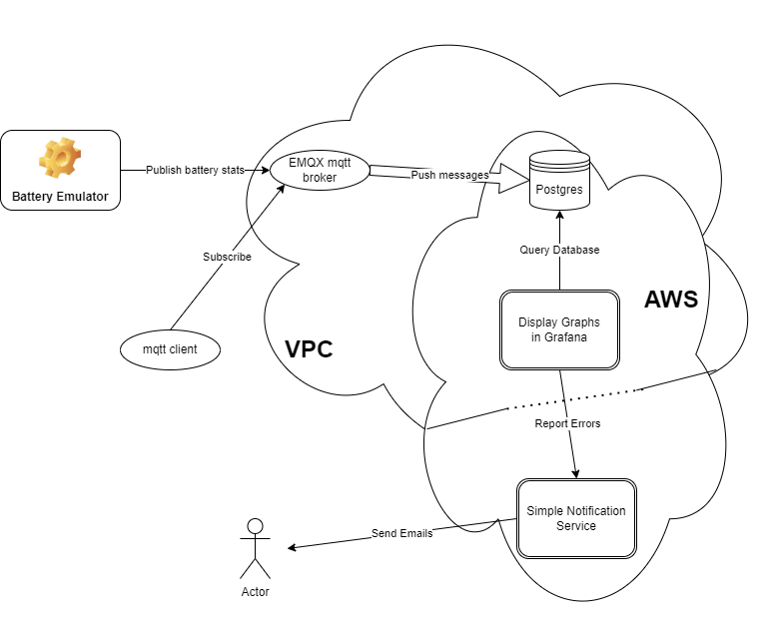

Database Schema
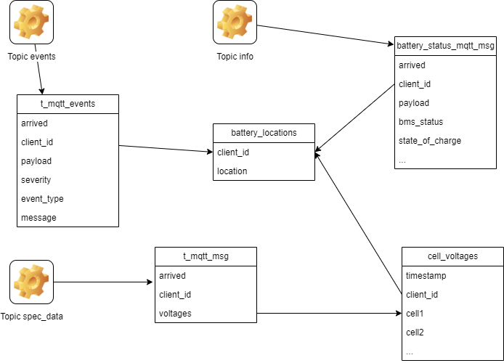

PC config
Install VSCode from https://code.visualstudio.com/download
Add the extensions C/C++, C/C++ Extension Pack and PlatformIO IDE
Install Git and Git Desktop (optional)
Install python 3
Clone repository from Github (currently at https://github.com/EncludeLtd/Battery-Emulator)

Useful tools
MQTTX client to monitor mqtt messages
Use the topic rangetherapy/sensor/# for all messages
Or
rangetherapy/sensor/+/info for general battery status
rangetherapy/sensor/+/events for events
rangetherapy/sensor/+/spec_data
The + stands for all clients, this may be replaced by the client id, in the development board this is battery-emulator_esp32-CFF924
pgAmin4 for database admin

EMQX platform
Login using https://accounts.emqx.com/signin
One deployment at j2ee4cd2.ala.dedicated.aws.emqxcloud.com port 1883 accepts all events pushed from the emulator(s)
Three rules are active
https://cloud-intl.emqx.com/console/deployments/j2ee4cd2/integrations/all/rule_details?id=rule-cf48a111 matches the /info messages
https://cloud-intl.emqx.com/console/deployments/j2ee4cd2/integrations/all/rule_details?id=rule-a586ed09 matches the /spec_data messages
https://cloud-intl.emqx.com/console/deployments/j2ee4cd2/integrations/all/rule_details?id=rule-111e1931 matches the /events messages
each rule has one action that takes the matching message, adds a timestamp, decodes the payload and sends the raw payload and the decoded fields to a Postgres database running on AWS
A virtual private cloud has been created to encapsulate the EMQX deployment, the Postgres database and the Grafana display package.

AWS Platform
This hosts the database and the Grafana display package
The database is at database-mqtt.cxmymmyeyegb.eu-west-1.rds.amazonaws.com
Grafana is at https://g-56ac810d1e.grafana-workspace.eu-west-1.amazonaws.com/dashboards

There are three dashboards
- Range Therapy dashboard that shows events and errors from all the sites.
- Cell voltages shows details from one site, using a picklist to select the site
- Admin dashboard that allows a battery locations table to be updated to show user friendly locations on the other dashboards.

Admin Dashboard
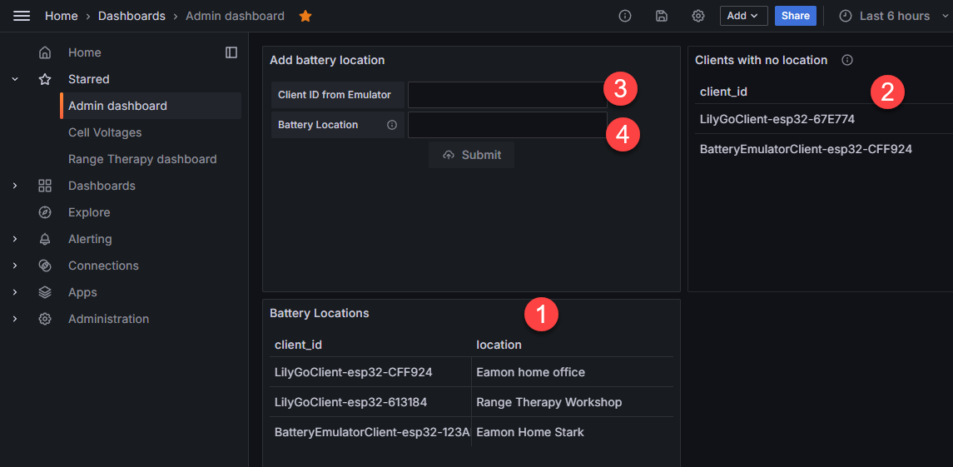
- The emulators that have been registered
- The emulators that have pushed data to AWS via EMQX but have not been registered
- Copy an id from an unregistered emulator into here
- Describe the location of the emulator here, then press Submit to add to the list of registered locations

To provide an SSH client for database admin, there is an instance of Amazon Lunix running in EC2, also within the VPC. Use pgAdmin if you need to edit the database directly.
Login to EC2 is restricted to specified IP addresses via SSH.
To give access to another IP address for SSH, got to https://eu-west-1.console.aws.amazon.com/ec2/home?region=eu-west-1#SecurityGroups:
In security group sg-0ac5bad340083ed27 - ec2-rds-1 add a new rule with Type SSH and source of your IP address.

AWS SNS
This is used to send email via two Grafana Alerts – one for power on notifications and one for Errors.
Because SNS is outside the VPC, an outgoing rule allows Grafana to send notifications across the VPC boundary.

Compiling the software in VSCode
The password for the EMQX broker is stored outside of github in USER_SECRETS.h
This file includes the line
#define MQTT_PASSWORD “emqxpassword”
In usersettings.h, set the battery used by remove the comment flag before the appropriate #define and remove Test_fake_battery
Build using the Build option in the Platform.io extension (alien icon)
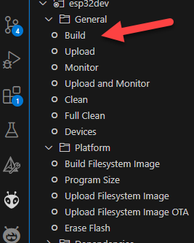
Send to the board using the Upload option.
When the board is connected to the USB port, Monitor allows you to see the debug messages
Once the board is running, connect to the Battery Emulator wifi, go to 192.168.4.1 and set the SSID and password for the host network.
Data should immediately start flowing to emqx

Costs
The EMQX broker is on their Dedicated Plan, because this supports unencrypted http messages from the battery emulators.
This costs $0.36 per hour (about $260 per month) and allows for 1,000 simultaneous sessions and 1,000 transactions per second.
AWS services are currently on the free tier which lasts for 12 months all prices after that are estimates.
Except for Grafana which is on a 90 day free trial which started in the first week of September
EC2 to host the virtual PC for pgAdmin $2.12 per month
RDS for PostGres on db.t4g.micro instance $12.41 per month
AWS managed Grafana is charged per active user per month
An “Active user” is any user that has logged in to an Amazon Managed Grafana workspace or made an API request at least once during a monthly billing cycle.
Admin and Editor users cost $9 each per month.
Viewers cost $5 per month
Currently two admins, so $18 per month
Total estimate for AWS services is $32.53 per month

Syncing with Dala’s main repository
From the terminal in VSCode
- Play safe by creating a new branch – from the last good local branch!
Click on current branch name 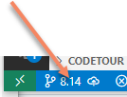
Select Creat a new branch from and enter new branch name 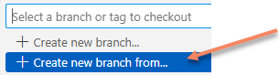
- Add the remote repository (only needed first time, use “git remote –v” to see if it is necessary)
git remote add upstream https://github.com/dalathegreat/Battery-Emulator.git
Fetch the latest changes with “git fetch upstream”
Merge in the changes with “git merge upstream/main” where “main” is the name of the datathegreat/Battery-Emulator branch you want to merge
If you want to marge a release e,g, 8.16, then the commands are
git fetch – tags upstream
git merge v8.16.0
This will result in merge conflicts fix them by clicking on the source control icon, 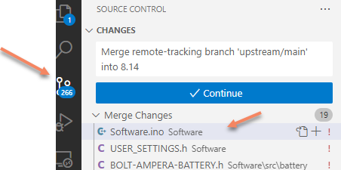 then for each file in the list click on it and then click on the “Resolve in Merge Editor” button
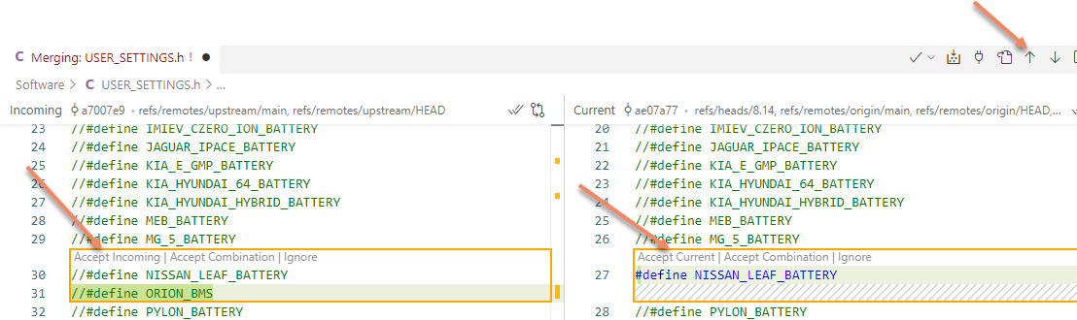
Use the up and down arrows to navigate to each change.
For each change click either “Accept Incoming” to use the change from Dala or “Accept Current” to use your change
When you have accepted all the changes click on “Complete Merge” and move to the next file
Do not define MQTT_MANUAL_TOPIC_OBJECT_NAME as the AWS system relies on the old naming convention
When all the changes are resolved, commit them with
git commit –m “some message”
then push to github with
git push

To build from a branch
From VS Code, in the Battery-Emulator folder, type “git pull”
Switch to the branch with “git checkout “ <branchname>
git checkout 8.14
The click on the PlatformIO (alien) icon and click Upload

